 | How plants Affect the oxygen levels of a fish tank.
11/12/2013 | Affect of Live Plants on Oxygen Level
 | By: Ben Chaleki

Grymes Science Fair Project 2013

Affect of Live Plants on Oxygen Level

Question:
How do live plants affect the oxygen and nitrate levels of a fish tank?

Hypothesis
All animals need oxygen to breathe which is necessary for life. How is this oxygen made? Oxygen is made by plants through the process of photosynthesis where the co2 is taken and converted into oxygen. Fish are also animals so they need to breathe too. That means there must be oxygen underwater. This oxygen is called dissolved oxygen and is created by aquatic plants. This would mean that if living plants are added to an ecosystem, then more oxygen will be present in the water.

Materials
- Two ten gallon fish tanks.
- Two water heaters (just to keep the temperature stable).
- Aquatic soil.
- Aquatic plants
- Fish
- Dissolved oxygen test kit
- Nitrate test kit
- Water
- Fake plants
- Journal

Procedures
- Add soil to both tanks until there is 2 inches at the bottom.
- Add 9.5 gallons of water to the tanks.
- Allow 1 day for soil to settle. (to speed up this process add a filter).
- Add live plants to one tank and fake plants to the other.
- Add fish is bags to top of water (just to adjust to temperature). Allow two hours to adjust.
- Release the fish into the tanks.
- Test for oxygen and nitrates in each tank.
- Every other day repeat step 7.

Data

Data – Tank 1: Nitrates

Day | Nitrates (ppm)
1 | 5
2 | 5
3 | 5
4 | 5
5 | 5

Graph – Tank 1: Nitrates

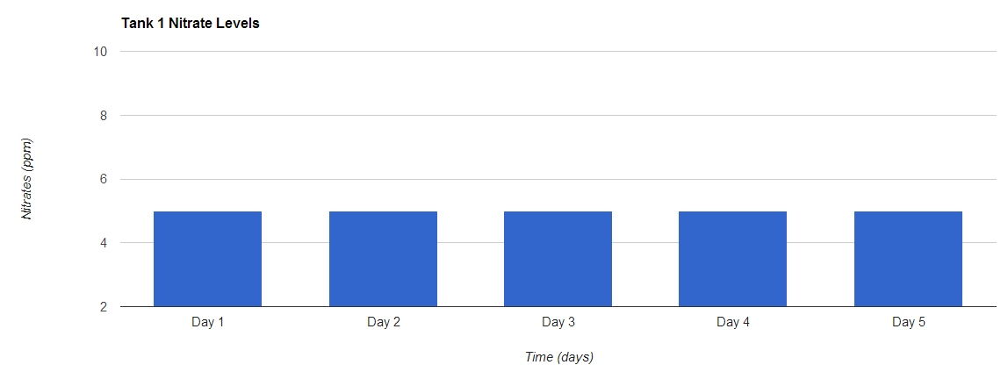

Data – Tank 1: Oxygen

Day | Oxygen (ppm)
1 | 9
2 | 11
3 | 10
4 | 9
5 | 9

Graph- Tank 1: oxygen

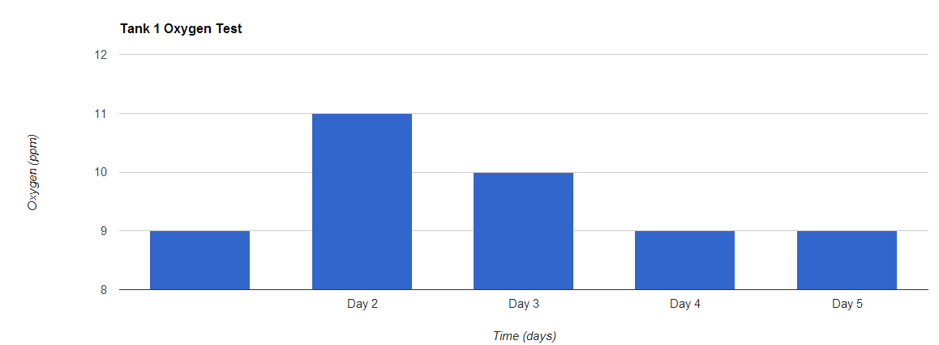

Data- Tank 2: nitrates

Day | Nitrates
1 | 5
2 | 5
3 | 5
4 | 5
5 | 5

Graph- Tank 2: Nitrates

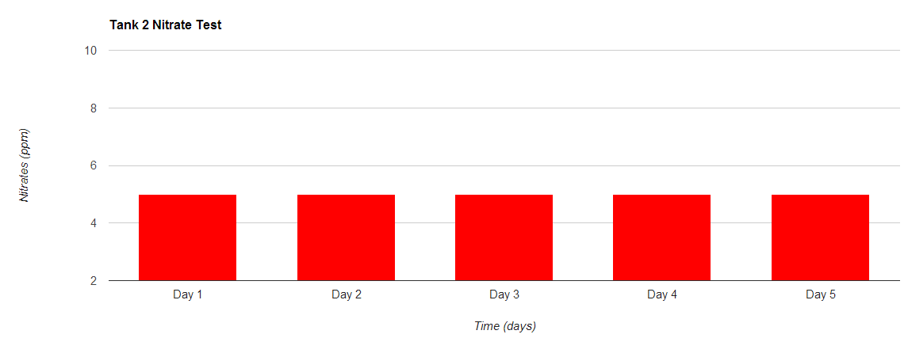

Data- Tank 2: Oxygen

Day | Oxygen (ppm)
1 | 5
2 | 4
3 | 5
4 | 7
5 | 6

Graph- Tank 2: oxygen

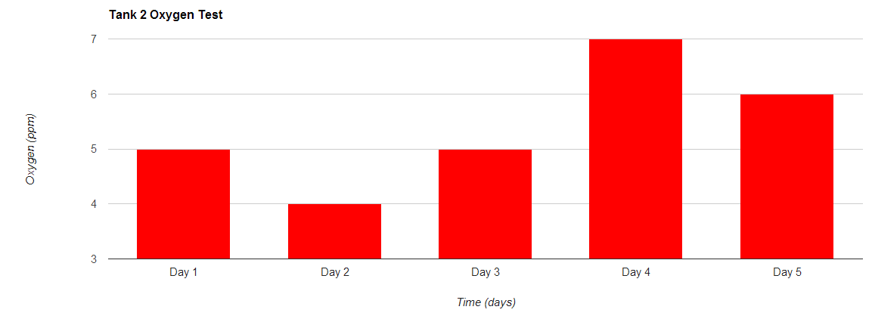

Results
I placed two inches of dirt into tank 1 and two inches of dirt into tank 2. I then added 8.5 gallons of water to each. This process kicked up a lot of dirt so I had to let it sit for 24 hours. After the water cleared up, aquatic plants were added to the bottom of the tanks. After letting it sit for a week, I began testing.
My first test showed a great difference in oxygen between the two tanks. Tank 1 (which contained plants) contained 9ppm of oxygen while tank 2 (without plants) contained only 5ppm of oxygen. This was a difference of 4ppm. This showed that the plants were producing oxygen. Test two showed the same pattern. Tank 1 contained 11ppm of oxygen while tank 2 had decreased to 4ppm. Again the plants were producing oxygen in tank 1, but without the plants in tank 2, oxygen was just being taken out of the water by the fish.
Test 3 was very interesting. It went against the normal pattern. In tank 1 the oxygen dropped down to 10ppm, while in tank 2 the oxygen increased to 5ppm. This was reverse of what had been happening.
It continued this pattern in test 4. The oxygen greatly increased in tank 2, but dropped again in tank 1. Tank 1 contained only 9ppm and tank 2 contained 7ppm. They were very close together now. This was going against the hypothesis which stated that if plants were added, then the oxygen levels in tank 1 would go up.
On day 5 the tests were going back in the right direction. The oxygen level in tank 2 fell back to 6ppm and the oxygen levels in tank 1 stayed the same at 9ppm. We can infer that if the test had continued, the oxygen in tank 1 would’ve increased again and in tank 2 it would’ve decreased.

Conclusions
According to these results we can see that the oxygen levels in tank 1 were generally much greater than in tank two. The oxygen levels in tank 2 did rise, but still never caught up to tank 1. According to the data, the hypothesis that state that if plants are added to an aquatic ecosystem, then the oxygen level will rise, was proven to be correct.
In tests one and two an increase of oxygen could be seen in tank one while in tank two the levels fell. However in tests 3 and 4 it was a different story. The oxygen levels in tank 1 began to fall, but in tank 2 they rose. This was the opposite of tests one and two. There are some factors that I think could cause this anomaly.
Halfway through my experiment, I began to notice some plant decay. Basically what this means is that some plants were beginning to die and rot. When things rot underwater this affects the ecosystem. When things die underwater, they produce lots of nitrates. You would find nitrates in things like fertilizer. They help plants to grow and therefore produce more oxygen. But in tank 1 it was the plants who were dying so the nitrates were left to float in the water.
I needed to find a way to fix the problem of plants dying. There was less oxygen being produced. We discovered the problem was the light. The regular LED light wouldn’t cut it. We had to get a special UV light which was supposed to replicate the sun’s rays. A UV light produces light at a “red” wavelength. The light isn’t visibly red though. This is the light the plants need to survive.
The next problem was the temperature of the water. The thermometer hovered around the 64 degree mark which was almost ten degrees below what the fish needed to survive. To address this issue, a heater was added into each tank. It was hard to keep the temperature steady though. Sometimes it was at 75 degrees, other times the temperature was 80. There was no way to keep it steady.
So why is temperature important? First off fish need the water to be a certain temperature. The particular type of fish I had needed the water to be 72 degrees. Temperature wasn’t only important to the fish though. Temperature has an effect on how much dissolved oxygen water can hold. The warmer the water gets, the less it can hold. If I tested one tank at 75 degrees and one at 68 there could be a difference in how much oxygen it could hold. Naturally this would change the results.
If I had to do this experiment again I would change a few things. First, I would probably change the type of fish I got. I would get fish that could survive in 65 degree water so I wouldn’t have to worry about heaters. Secondly I would install a UV light from the start. I would keep it on for twelve hours and off for the other twelve hours. The reason I would do this would be to replicate day and night. This would also keep the algae levels down. Finally I would start with a base test. I began testing after adding the plants. I should have started with a test with nothing, no fish, and no plants. This would just give me a base to start out with.
Other considerations would be using a filter and aerator, but there was a reason I didn’t use these two devices. They would go against what I was trying to test as they both add air to the water. Filters add the aerated water back to the tank and an aerator does the same. That is why I didn’t use either.
I do believe that in the end it was a successful experiment. My hypothesis was proven. Plants do add oxygen to an aquatic ecosystem.

